**WIA1002/WIB1002/WXES1117 : Data Structures**

**Tutorial 3 : Recursion (Applications)**

In information theory, one of the most important topics is data representation. Some of the representative examples of using bitstring for data representation are ASCII for character and IEEE-754 for floating point number. We can also use arrangement of items to represent data. For example, suppose there are $t=4$ items (think about apples if it helps) and $s=3$ baskets. Here, the relative order of all items must be preserved. There are exactly 15 ways to group 4 items (denoted by $x_{1},x_{2},x_{3}$ and $x_{4}$) into 3 baskets ( $s_{1}, s_{2}$ and $s_{3}$) as shown below, and each arrangement can be associated to some value / character / symbol / etc.

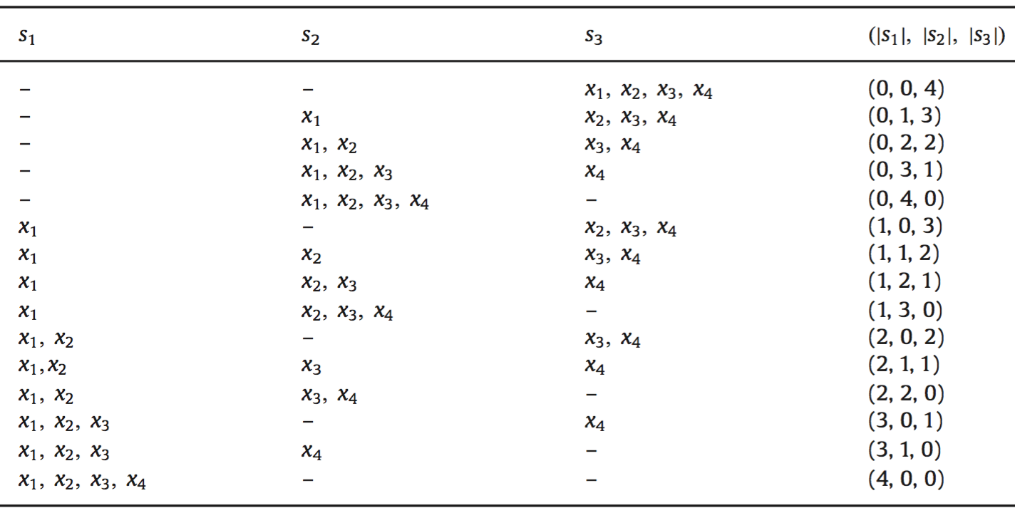

** The relative order of the items must be preserved. Given $x_{m}∈s_{j}$, then $x_{n}∈s_{k}$ for $n > m$ and $k≥ j$.

1. Find the values for $x,y,z$ and $w$ in Table 1.

Table 1. The number of possible arrangements given $s$ and $t$

|  |  |  |  |  |  |
| --- | --- | --- | --- | --- | --- |
| s / t | #baskets = 1 | 2 | 3 | 4 | 5 |
| #items = 1 | 1 | 2 | 3 | 4 | 5 |
| 2 | 1 | 3 | $$x$$ | $$y$$ | $$z$$ |
| 3 | 1 | $$w$$ | 10 | 20 | 35 |
| 4 | 1 | 5 | 15 | 35 | 70 |

*Hint:

- When there is only one basket ($s = 1$), there is only one way to arrange the items.

- When there is only one item (i.e., $t = 1$), there are exactly $s$ possible arrangements.

1. By studying at the values in the table, write the recurrence equation that governs the number of arrangements $F(s,t)$, $s$ and $t$.

* Hint: Recall that $n! = n × (n-1)!$ If we let $f(n) = n!$, then $f(n) = n × f(n-1)$.

1. Based on recurrence equation found in part (b), find $F(4,6), F(4,7), F(4, 15)$, … $F(5,1)$, …, $F(14,14)$ by using MS Excel, viz., expand Table 1 up to $s = 14$ and $t = 14$.